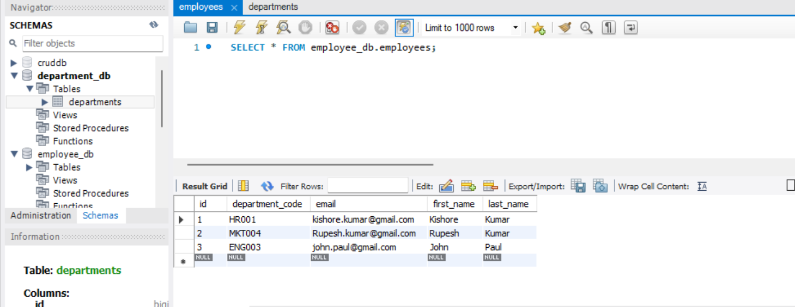

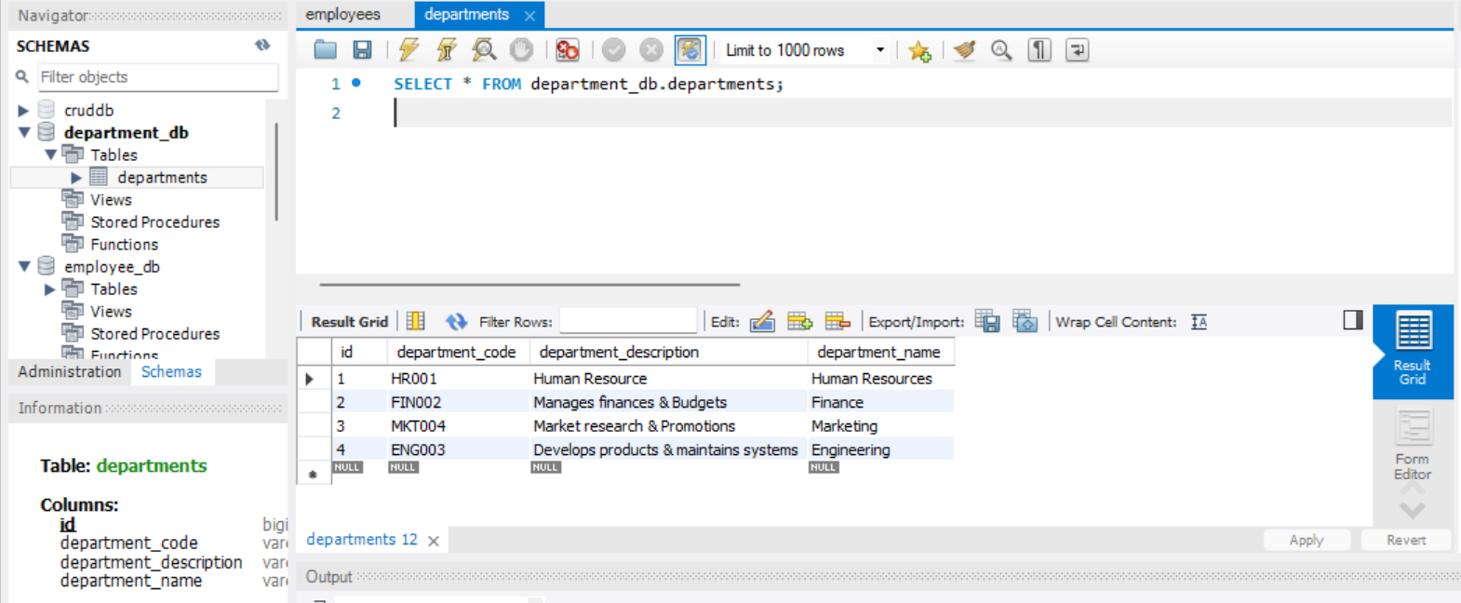

GET : <http://localhost:8081/api/employees/2>

{

"employee": {

"id": 2,

"firstName": "Rupesh",

"lastName": "Kumar",

"email": "Rupesh.kumar@gmail.com",

"departmentCode": "MKT004"

},

"department": {

"id": 3,

"departmentName": "Marketing",

"departmentDescription": "Market research & Promotions",

"departmentCode": "MKT004"

}

}

=====================================================================

GET: <http://localhost:8081/api/employees/1>

{

"employee": {

"id": 1,

"firstName": "Kishore",

"lastName": "Kumar",

"email": "kishore.kumar@gmail.com",

"departmentCode": "HR001"

},

"department": {

"id": 1,

"departmentName": "Human Resources",

"departmentDescription": "Human Resource",

"departmentCode": "HR001"

}

}

=====================================================================================

GET: <http://localhost:8080/api/departments/HR001>

Output:

{

"id": 1,

"departmentName": "Human Resources",

"departmentDescription": "Human Resource",

"departmentCode": "HR001"

}

=========================================================================

POST: <http://localhost:8081/api/employees>

{

    "firstName":"Kishore",

    "lastName":"Kumar",

    "email":"kishore.kumar@gmail.com",

    "departmentCode":"HR001"

}